FULL TRANSCRIPT FROM SUPERINTENDENT HEATHER PERRY:

Question: Can you explain the 1-4 grading scale? How do high achieving students stand out if all students use the same 1-4 standard?

First and foremost, it is important to understand that within a PBL system, the expectation is that ALL students are expected to learn. This is consistent with our Core Beliefs and with our Vision.

In regards to the same standard of 1-4 piece, it would be my hope that students under the traditional 100 point scale all had the same standard as well, and that all students had opportunities to excel and differentiate themselves from one another if they so desired. This should be no different with the utilization of a 1-4 scale. Students still have the opportunity to “stand out” and to stand out significantly, they just do so slightly differently and with a slightly different number next to their name on a report card.

I think an important thing to understand is that within a PBL system, a 1-4 grading scale absolutely still offers that ability for students to “stand out”. Allow me to be more specific: For EVERY PERFORMANCE INDICATOR across grades K-12 there is an opportunity for EVERY student to reach a “4”. Now, that might not mean, however, that for every assignment there is an opportunity to meet a “4” but for every summative assessment on a performance indicator, there is. When our teachers constructed this system, they paid close attention to this because they too wanted to make sure that every student could challenge themselves and excel if they chose to do so. In order to achieve a 4 on this scale, students must demonstrate their understanding of a particular skill at a higher level than others. They must go deeper in their learning and be able to use that learning in multiple ways. When you read a scoring criteria scale, you can see what I mean. Here are just a few examples:

8th Grade ELA: Graduation Standard: Writing Argument. Chart below shows TWO Performance indicators and their “scoring criteria” – both having very clear opportunities for a “4”:
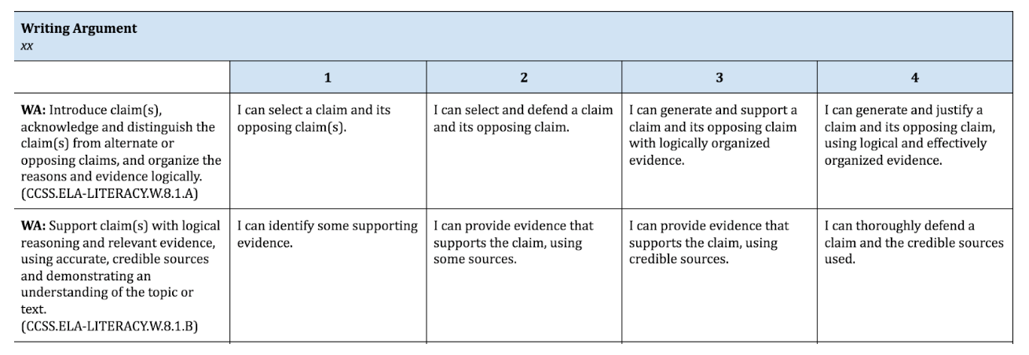

Here’s a few for Math. This one is from 6th grade math. Graduation standard is Algebra and there are two performance indicators, both with clear scoring criteria and opportunities for “4”s.

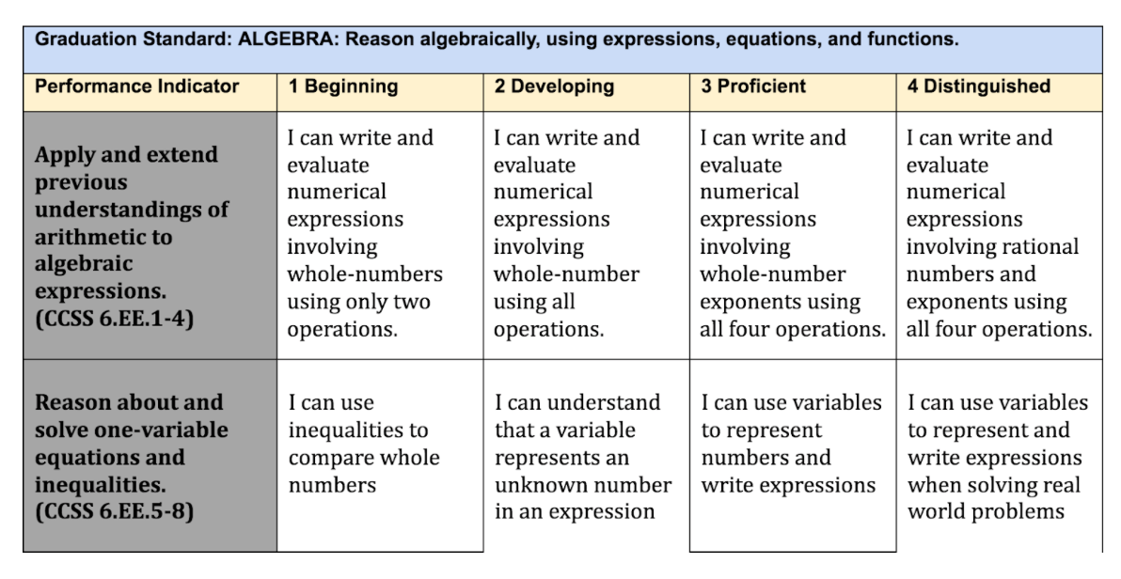

I could share more, but it would be easier for people to check out our website and see them all – EVERY SINGLE PERFORMANCE INDICATOR (PI) has an opportunity for a “4”.

I will admit that there is a piece here that is likely very confusing and that we need to do a better job of communicating. It’s the piece around pre-assessment. We’ve all had teachers in our own education who taught us things we already knew or weren’t yet ready to learn. You know from your own experiences that this is not best practice. What’s best is when a teacher finds out what a student already knows so that he or she can provide the best possible approach for students to learn. Often times when teachers are formatively pre-assessing students on their knowledge, they are doing so at the “level 3” learning so they can see what students already know, what students may need more work in, and what students may be well above the level 3 learning already. When they do this, if they aren’t communicating well with students, a student might think they didn’t have an opportunity to get a “4” when in reality, this was not the purpose of the assessment. Again, this is something that we likely need to do a better job at communicating – but I hope you can see from the charts above, and those linked from our website – EVERY PI allows for a “4” and every teacher provides opportunities for every student to demonstrate proficiency at the “4” level on summative assessments.

I also hope that you can see that demonstrating a “4” on the scoring criteria is A LOT HARDER than demonstrating a “3”. These scales are purposefully written this way so that demonstrating a “4” requires you to do work at a much higher level of rigor than required to achieve a 3. This means that students who want to stand out absolutely can. In our traditional scoring system, every student had an opportunity to achieve a 100, but not everyone did because it was much harder to do so. The same applies on the 1-4 scale.

Folks fear there isn’t as much room to “differentiate” because there are only 4 points, but when you read the scoring criteria, you can clearly see there are lots of ways to differentiate and it is not at all “easy” to get a “4”. In our 1-4 system, teachers can also score using .5 increments and in Jumprope, because we use “decaying average,” scores are calculated on a tenth of a point scale. You can see, for example, students that score a 3.2 or a 2.8. Additionally, we continue to calculate GPA’s so students still can receive honors, high honors, etc. and we can still do things like select Valedictorians, etc.

Overall, the main difference between the traditional scale and the proficiency scale is in the depth of understanding a student needs to show. The traditional scale was based on a percentage of questions a student got right. For example, a student who got every question right got a 100 because he or she got 100% correct. A student who got half the questions right got a 50%. While this makes sense mathematically, it begs the question how many times does a student need to show that he can multiple integers to demonstrate that he knows how to do it? In the newer system, we want students to demonstrate how well or to what extent they can do something. That is why the 4-point scale is based on degrees of understanding, not just a percentage of times a student can perform a task.

Question: Recognizing that it’s a work in progress, do you think the model has been effective so far in Gorham? How do you respond to skeptics of PBL?

With the understanding that progress indeed does not occur overnight, I think that there have been many success stories for our PBL implementation so far here in Gorham. Do we still have lots of work to do? Yes, we absolutely do – but I think we have accomplished a great deal in a fairly short amount of time, and that we are constantly reviewing our methods, investigating new strategies, and adjusting our teaching practices to best meet the changing needs of our students. Students today are very different than students 10, 15, 20 years ago and we are preparing them for a very different world. Because of this, we need to do things differently.

In terms of our success, I think the largest one has been our focus on providing increased feedback to students on their learning. In the traditional 100 point scale system students often would receive 83’s or 98’s or 70’s without truly knowing WHY they were getting those scores. Our PBL system requires teachers to align assessments to our Performance Indicators and scoring criteria, so that now when a student receives a score, they know what they did well, and what they might need to work more on in order to do better the next time. It is a much more targeted communication system to help our students better understand what they are learning, why they are learning it, what they need to do to demonstrate that learning, and what comes next once they do. Where I think we have fallen down is in our own communication as teachers as to what these various scales mean, and often more importantly, what they do not. One of the major tenants of our PBL system is to increase transparency of learning for our students and to bring them INTO the conversations about their own learning…and we need to do a better job here with more consistent practices and communication to parents and students.

For students in grades 6-12, this was our first year of actually implementing our graduation standards, performance indicators, and scoring criteria. As a result, there are indeed differences among our teachers in interpretation of the various parts of the system and how they work. Throughout the year we have continued to provide training to teachers, and will continue to do so, but building consistency and continuity (what we call “calibrating”) within such a complex system across grades 6-12 will take time. Each year we select a focus point for our work regarding calibration. This year’s focus has been on alignment of assessments to graduation standards and on scoring separately academic content from Skills for Life. Next year our focus will be on utilization of the scoring criteria and calibration of scoring processes for teachers so I hope that there will be a distinct improvement in those areas next year as we continue this work.

When responding to skeptics of the PBL system, I first try to ask – are folks skeptical of the PBL system or are they skeptical of the reporting system using a different grading scale? These are TWO VERY DIFFERENT THINGS. PBL practices in the classroom are all about making sure students know what they are learning (standards), why they are learning it (how it fits into the overall scope of their required learning), what they need to demonstrate their learning (at what level of rigor to get a particular score on the scoring criteria) and what comes next in their learning once they do. Not many people can argue that the instructional practices within a PBL system are the best instructional practices from the old traditional system, only placed within the context of a system that honors the fact that education is something we do with students, not to them.

Once that is cleared up, it’s usually all about the grading scales (a 100 point scale or a 4 point scale) and to me, this is the least important factor – although certainly the most visible component. In Gorham, we will not make any decisions that we feel will jeopardize the ability of our students to make whatever choice they want to regarding their post secondary aspirations when they leave our system. If that means we stick with a blended scale, we do…if that means we calculate GPA, honor roll, high honors, valedictorian, salutatorian, class rank, etc., then we will.

Some people have expressed concerns that a PBE system will make it harder for kids to get into college, and I need to correct this misconception. The reality is that many colleges in Maine and around the country, including top colleges, have stated publicly that a PBE system will not hurt their chances of getting into college. In fact, many colleges have shared with us that it will help them make admissions decisions because they'll have a clearer understanding of what the student knows and can do. Colleges we have worked with have pointed out that they look at grades from all over the world, including grading scales from countries in each content on the planet, which can look very, very different than our own, as well as home school transcripts, and grades and transcripts from schools who don't even give grades. My point is that colleges are very adept at figuring out whether a student will be a good fit for their institution. What many colleges have told us is that they want to see students challenge themselves in high school. For example, they want to see students take the most rigorous classes available and get the best grades available.

Question: What will the possible proposal to drop certain portions of PBL mean for teachers/students? What are the portions that may be dropped and why?

Right now, the proposal on the table is basically to “decouple” Proficiency from the diploma at the state level. In other words, although the state will still require students to meet proficiency, it will leave it up to the local school system to define what that means in terms of the diploma. This allows school systems to address two key areas of challenge that have been out there since the beginning of this work: (1) how to deal with special education students whom we know will not be able to meet grade level standards in order to graduate, and (2) how to deal with the fact that most schools in Maine (Gorham included) do not have the capacity to ensure students can meet proficiency in all eight content areas (our hardest being world languages) since our students don’t really begin learning FL until 9th grade). To be honest, Gorham began its journey towards creating a PBL system well before the state passed LD 1422 and I would envision that this work would continue regardless of what the state does. By making the adjustments they are working on now, it would allow us to adjust our systems so that students with special needs will still be able to graduate with a GHS diploma, as well as those students who may not have met proficiencies in a world language. We would basically be able to keep very similar practices to what we have always done when it comes to issuance of a GHS diploma.

Question: How can teachers/administrators help parent/students understand their progress/grades, i.e. students receiving 3.5 on a test despite getting all answers correct.

It actually does make sense…here’s how. Let’s say that a Math teacher is getting ready to assess students on their understandings of “one variable equations” which is the PI I used above as an example. Let’s say the “test” is a hand written test with 20 problems. Of the 20 problems, most ask students to simply create equations using letters for unknowns and to solve those equations. When you look at the scoring criteria, students can only get a “4” if they use these skills to solve “real world” problems. And here is where the communication issue lies that I referred to earlier. If this were a summative assessment or an assessment “of student learning”, then the teacher would ALWAYS provide an opportunity for students to demonstrate a “4” on the assessment. However, if this were a formative assessment “for student learning,” designed only to help the teacher know where the student was in their learning, they may not provide the opportunity for the 4 and so a student might indeed get all questions correct but only get a 3.5. This is that communication piece I was referring to earlier that WE NEED TO DO A BETTER JOB OF IT in helping students to understand that if this occurs, this was only a formative assessment, and that they will have ample opportunity to demonstrate the “4” on a future assessment. Teachers also need to do a better job of letting students know this, and maybe even offering those students who can, opportunities to demonstrate 4’s even on formative assessments.

Students and parents continue to have access to daily learning reports for student work in both Jumprope (used at grades K- 6, and in some subjects in grades 7 & 8) and in Infinite Campus (IC). Progress reports continue to be sent out. I would agree, however that we need to do a better job in communication here and we are working on that as we speak. Right now our energies are focused on making sure students know where they stand in their learning and how they can read scores on Jumprope and IC to know where they are and what they need to do to be successful.

Question: Is the below true as reported in a recent mainewire.com article? How can we ease parent/student concern over how Gorham students’ diplomas/GPAs will compare with others when applying to colleges.

“All major colleges and universities still use the traditional 1-100, letter grading scale, as do most states. For a Maine student who wishes to attend college outside of Maine at an institution that has no relationship with the Maine high school, the student’s chance of acceptance will likely be affected if the institution must go through lengthy research to determine how Maine’s education model stacks up with the rest of the nation, or how the Maine student’s scores compare to other students whose transcripts reflect the traditional grading scale.”

Short answer is NO! This is absolutely FALSE! Just last spring, we brought together admissions officers from Bates, Bowdoin, Colby, Thomas, and USM to discuss how they determine admissions decisions at their universities. Most major colleges and universities use a 4.0 GPA scale. I’m sure you remember this from your own experiences in college as do I. What all colleges and universities do is they take whatever transcript they are given in whatever form it is given and they translate it to their own 1-4 GPA scale so that they can compare it across students from various states, from various countries, and from homeschooling, etc. Every institution already does this so there would be no negative impact to a student’s chance of acceptance based upon their transcript scores. What universities base their decisions on are: How did the student do on their SAT’s? Did the student challenge themselves? Did they take the most advanced courses offered at the high school that they could? Did they participate in extra and co-curricular activities? Did they participate in their community? Are they well-rounded individuals? These are the things colleges/universities – ESPECIALLY those for Ivy League type schools – pay the most attention to, not the grades on the transcript because they already assume those will be pretty darn good.

Right now, GHS provides a total score on the 100 point scale using our “blended scale” approach. This scoring is no different than it has always been. We still give grades, and we will always give grades. In the future, we do plan to move to a 1-4 scale; however when we do, we will continue to calculate a 4 point GPA so that we can continue to calculate honors, high honors, class rank, etc. Finally, as I said earlier, the top rank schools all convert their applicants transcripts into their own scale and they already assume student’s GPA’s will be good – otherwise, why would they apply? What sets students apart in those decisions is what else they do on top of academics! I would tell parents to first, try to make sure your student takes the most rigorous classes they can. Perhaps Advanced Placement classes or early college opportunities. Second, help students to focus on those “other” things that I referred to above (while maintaining good grades of course)…to participate in those clubs, or to play that sport, or to volunteer those hours to do this and that for the community, to be involved, fully involved in their education. I would encourage our students to keep doing the things our students traditionally do well in, which is why our students traditionally have always been able to get into the school of their choice!

I thought it is also important to know that every state differs in how it does this. Mass. does a 4 point GPA for example, Connecticut does 100 point scales for the most part, and Vermont has a large number of its schools that give NO GRADE AT ALL, and only provide narrative transcripts!

Question: In the current system, students can retest until they are proficient in a subject. How is this teaching them life skills about working hard to “get it right the first time”?

First, we want students to put in their best effort at ALL TIMES, however we also understand that learning is indeed a process and that no one ever gets anything 100% right the first time they try it. We assess students on their effort and on their preparedness for class (like turning homework in on time) through their Skills for Life grade. This grade appears on the report card and it will appear on their transcript, so it is important. Colleges see it…and they never have before – so to me, this is placing a much greater emphasis on turning work in on time and participating in class, etc. Our Skills for Life is important and this is an area that we are focused on, not losing because of PBL.

The ultimate goal of our educational system has always been, and continues to be, that students LEARN the materials we are asking them to learn. We want every student to walk across that stage with at least a minimal demonstration that they have actually learned all that we need them to learn. Some may go well above that level (and most GHS students do), but we want all students to learn the things we think are essential, which are defined by our standards.

If a student does poorly on a formative assessment that a teacher has given just to see where students are at, that is fine…that informs the teacher of where they are in their learning of that particular topic so that the teacher knows what type of instruction to use to help the student to learn. Formative assessments are assessments “for learning” that teachers use all the time to inform instruction. Summative assessments, however are assessments “of student learning.” These are more like your traditional tests or projects. These are assessments where students are asked to demonstrate their learning so teachers may “grade them.” Students are given multiple opportunities to demonstrate their learning on specific standards. So if students don’t do so well on one assessment, they may do better on a future one. The goal is that students learn. So yes, they are given multiple opportunities to do so just like students can take the SAT multiple times, or they can take their drivers license test multiple times, or a lawyer can take the bar test multiple times, and even doctors can take their certification tests multiple times. The goal is to make sure the students learn the materials. High achievers have the ability to demonstrate their learning at higher and more complex levels…to me this is the motivating factor…to show that not only do “I know it” but I know it this much more deeply than I need to! Hasn’t that always been the motivation for “high achievers”?

Final Thoughts from Supt. Perry:

Gorham has always been, and will always continue to be, a school system that supports excellence among its students. Motivation and high achievement are embedded within a school’s culture - they are not achieved through a grading system. Our school culture will continue to promote students challenging themselves to be their very best, it will continue to poke and prod and conjole students to excel, to demonstrate their very best knowledge, and to never be satisfied by doing “just enough to get by.” Our students could do that in the old system, right? I mean students have always been able to “skate by” with 70’s or 80’s and be just fine. They could “pass” and graduate and be on their way. This has never been what we want, but it has happened. The point is, it’s not because of the 100 point scale. It’s because our teachers hold our students accountable to excellence, its because students hold each other accountable to excellence, it’s because parents hold their students accountable to excellence. PBL doesn’t change that…only a school and or a community’s culture can change that.

